**Problem Statement:**

You work for XYZ Corporation. Your corporation wants to launch a new

web-based application and they do not want their servers to be running all the

time. It should also be managed by AWS. Implement suitable solutions.

**Tasks To Be Performed:**

1. Create an Elastic Beanstalk environment with the runtime as PHP.

2. Upload a simple PHP file to the environment once created.

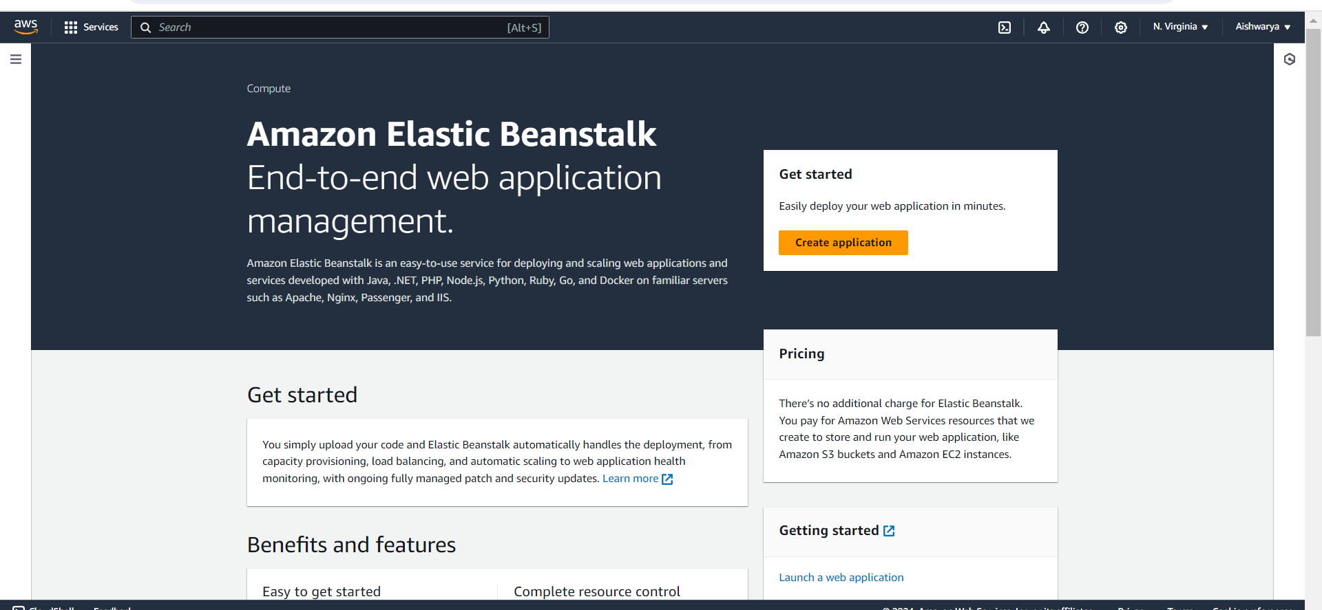

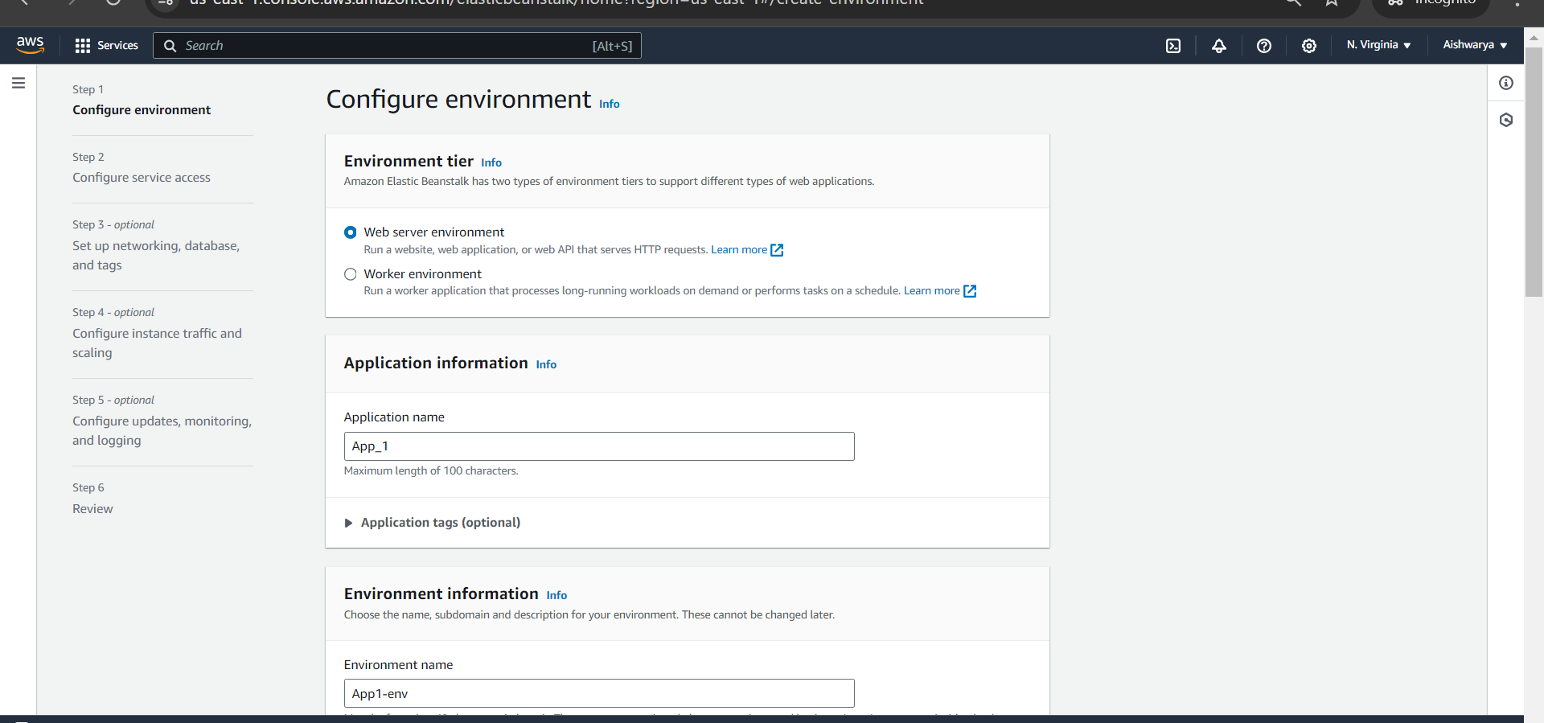

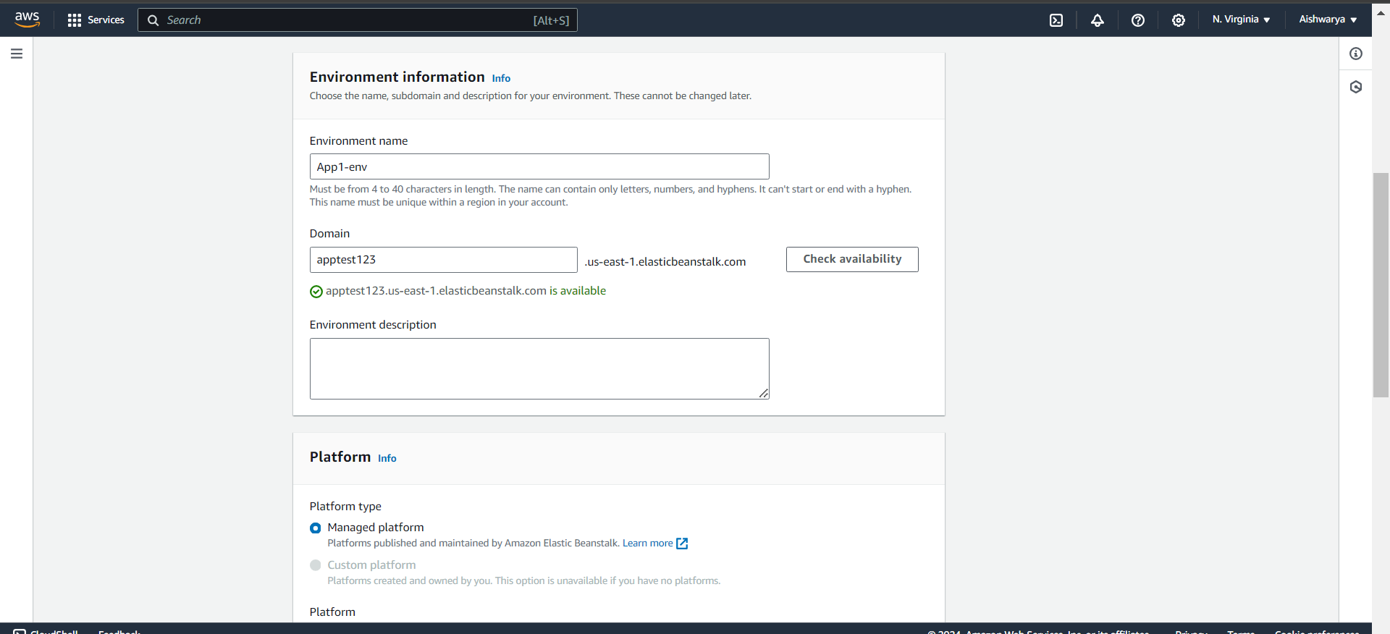

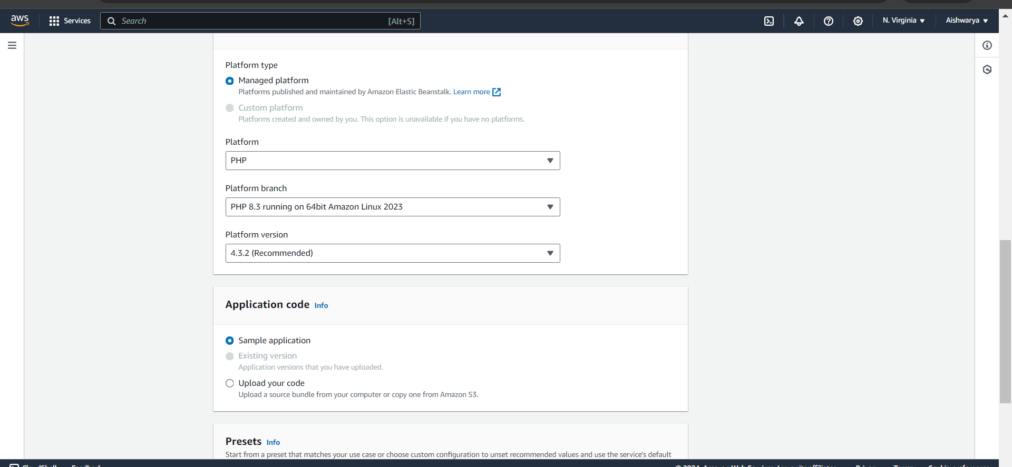

Create 2 roles

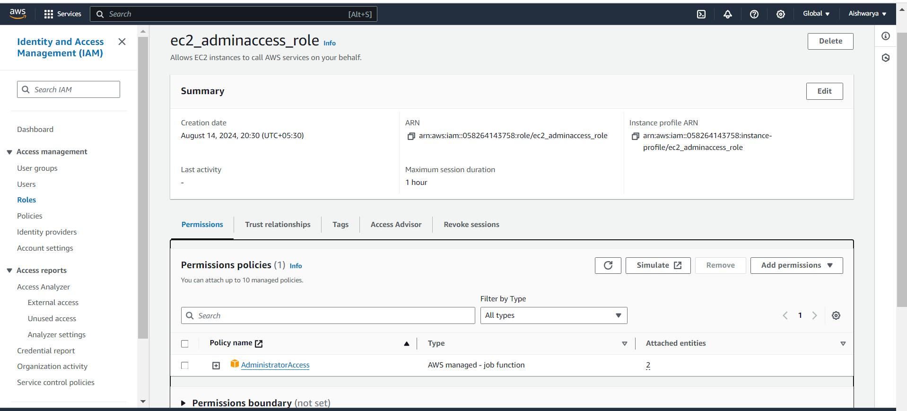

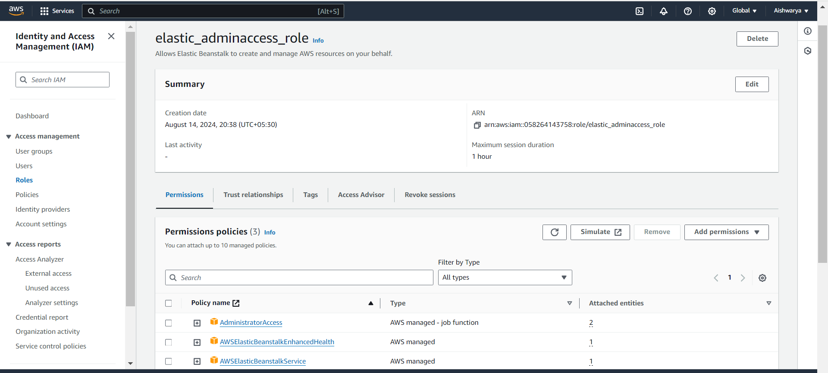

Add two roles

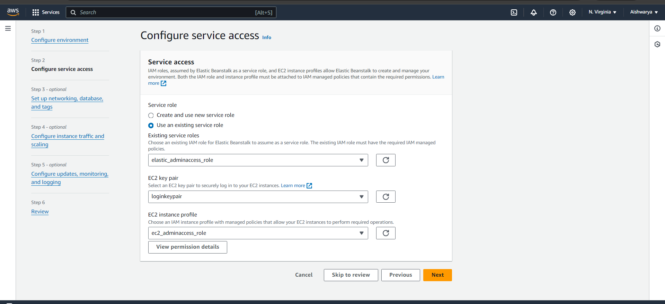

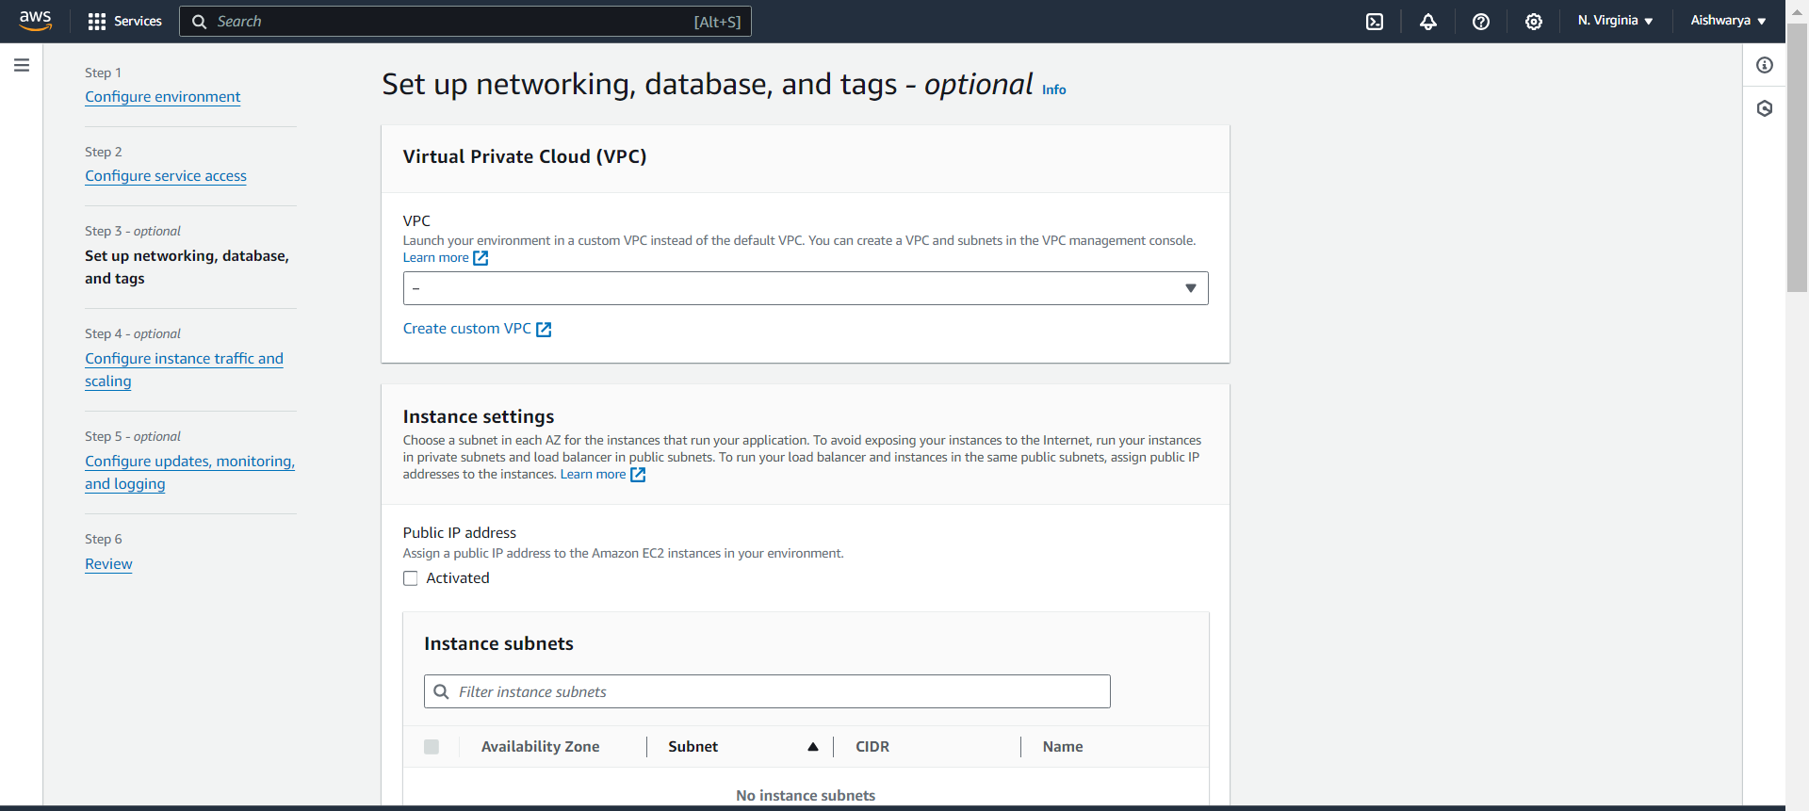

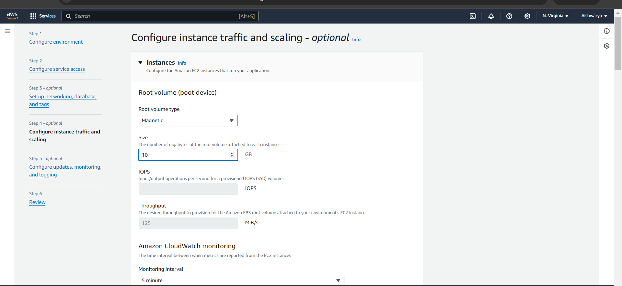

Put rest default and create application

Take domain name

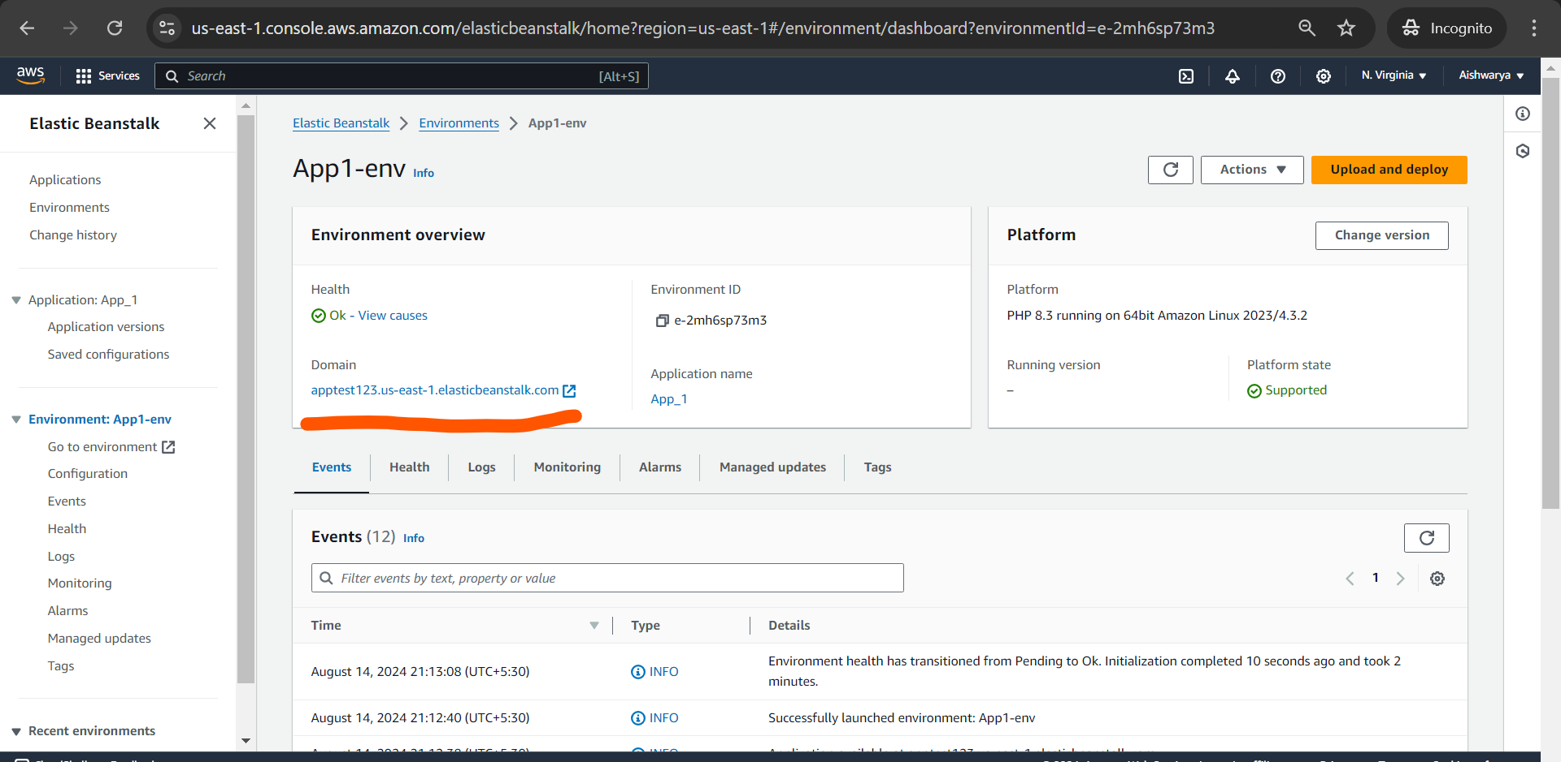

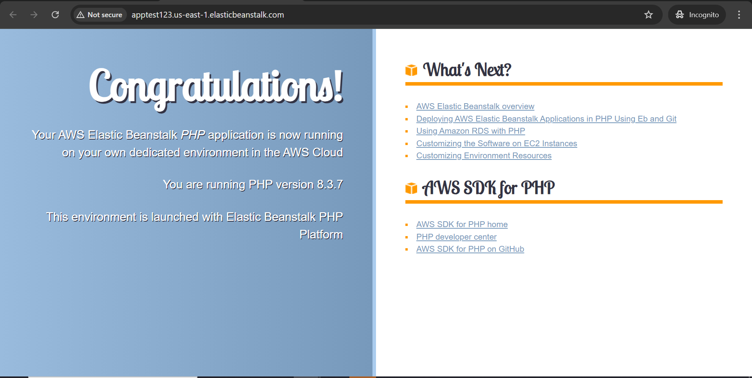

Now upload sample PHP zip file by upload and deploy option

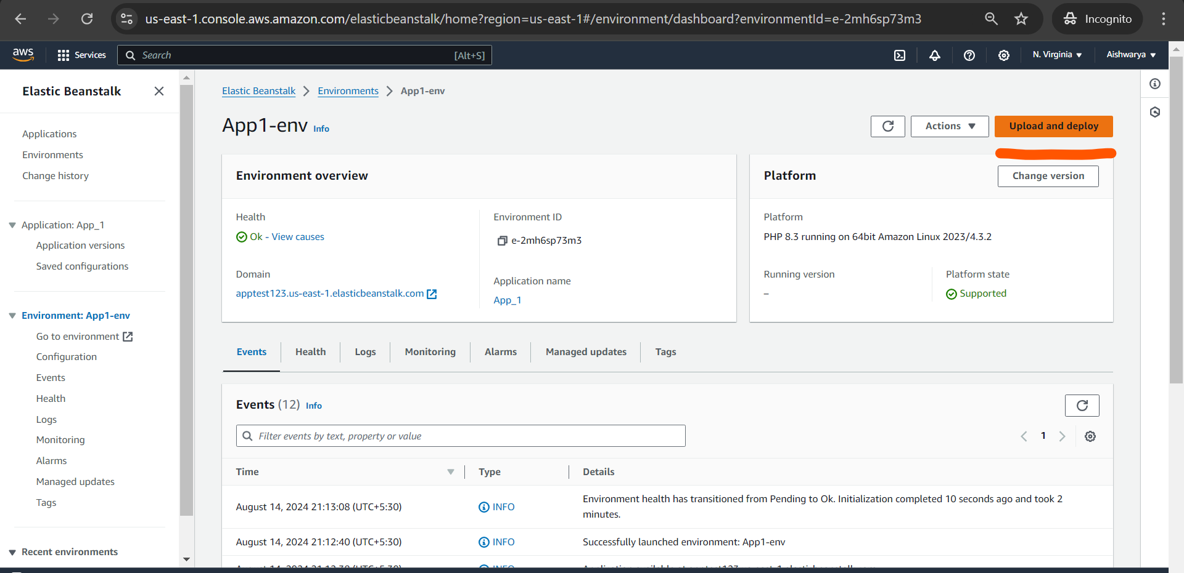

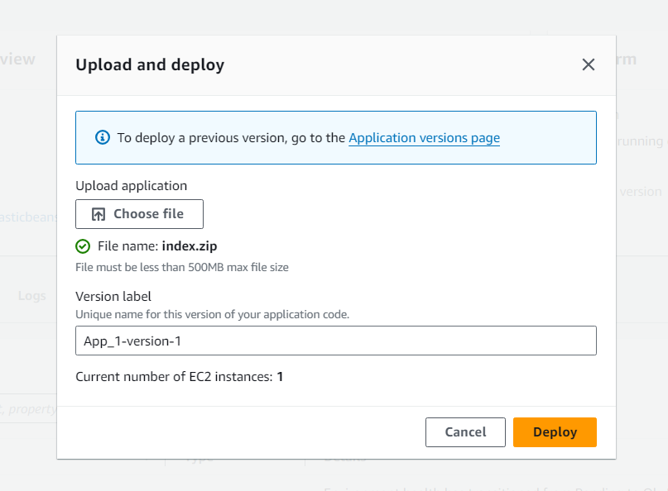

Now it shows

